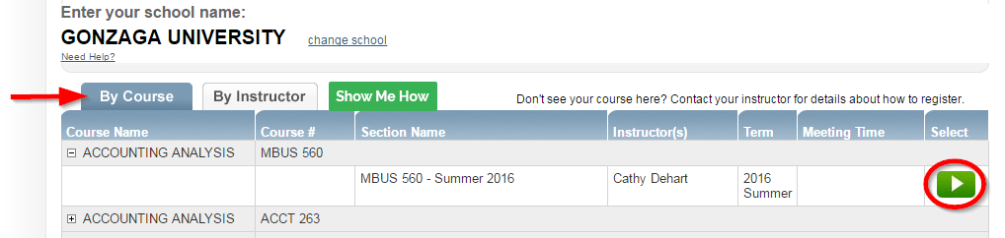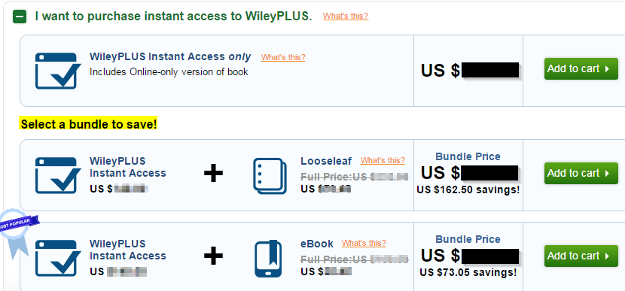

**Option 2)**  Visit www.wileyplus.com

-*Enter school name*

*-Select by course or instructor name*

*-Then select the play button*

**Class URL:**

***Student Registration—2 options!***

**Option 1)**  Use unique URL for your class

**Final Step)** Sign in or create an account *(agree to the terms)*

*Now you have the option to add a loose-leaf or eBook*

WileyPLUS Live chat support:

www.wileyplus.com/support

**Getting Started with *WileyPLUS* #rightfromthestart**

***- OR -***

**Final Step)** Sign in or create an account *(agree to the terms)*

*Now you have the option to add a loose-leaf or eBook*

**Option 2)**  Visit www.wileyplus.com

-*Enter school name*

*-Select by course or instructor name*

*-Then select the play button*

WileyPLUS Live chat support:

www.wileyplus.com/support